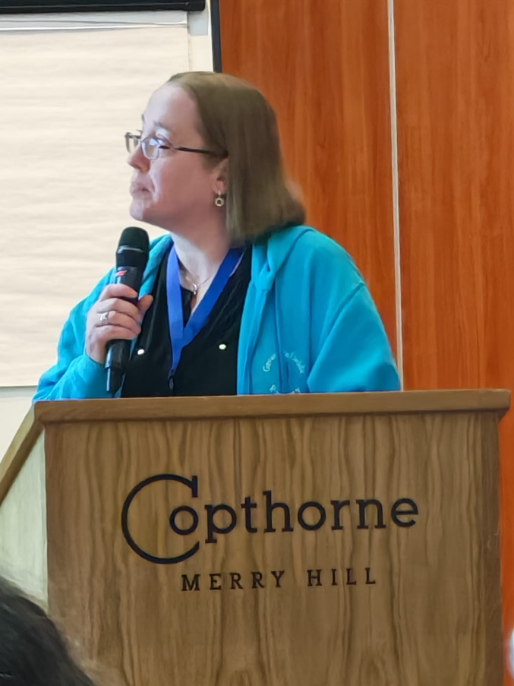
On March 12th 2026, our Resource Provision manager, Mrs Fox, attended the VIEW conference and presented some of the work being carried out at Great Binfields Primary School to implement the Curriculum Framework for Vision Impairment (CFVI).
VIEW’s Annual National Conference is the UK’s leading professional development conference designed for QTVIs and other professionals supporting children and young people with vision impairment, primarily in mainstream settings.
The conference brings together leaders and practitioners to share ideas for supporting the education and development of children and young people with vision impairment.
If you would like to find out more about our work being done to implement the specialist framework, please contact Mrs Fox. R.fox@greatbinfields.hants.sch.uk

