
Cubed number?
____________

Squared number?
______________

Prime number?
___________


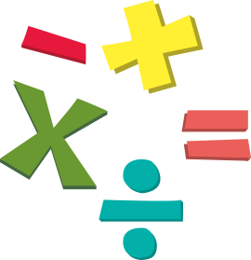




Halve it
_______________________

Double it
_______________________

Multiply by
10 = __________
100 = ___________
1000 = __________

Divide by
10 = __________
100 = ___________
1000 = __________

Less than
10 less = __________
100 less = __________
1000 less = __________
10, 000 less = ___________
100, 000 less = ___________
1,000,000 less - ___________

Multiples

Factors

Place Value
Thousands - __________
Hundreds - ___________
Tens - ______________
Ones - ___________
Write a multi-step problem that has this number as the answer.
___________________________________
___________________________________
___________________________________
_______________________________

More than
10 more = __________
100 more = ___________
1000 more = __________
10, 000 more = __________
100, 000 more = __________
1,000,000 more - ___________

NUMBER

